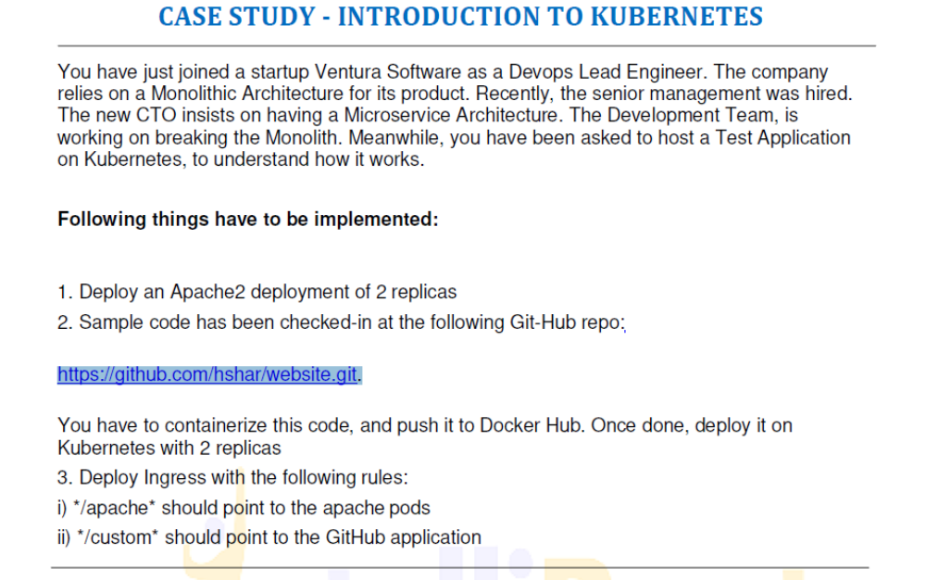
ubuntu@ip-172-31-28-92:~$ sudo nano apache.yaml
ubuntu@ip-172-31-28-92:~$ cat apache.yaml
apiVersion: apps/v1
kind: Deployment
metadata:
name: apache-deployment
labels:
app: apache
spec:
replicas: 2
selector:
matchLabels:
app: apache
template:
metadata:
labels:
app: apache
spec:
containers:
- name: apache
image: httpd:latest
ports:
- containerPort: 80
ubuntu@ip-172-31-28-92:~$ kubectl apply -f apache.yaml
deployment.apps/apache-deployment configured
ubuntu@ip-172-31-28-92:~$ git clone https://github.com/hshar/website.git
Cloning into 'website'...
remote: Enumerating objects: 8, done.
remote: Total 8 (delta 0), reused 0 (delta 0), pack-reused 8
Unpacking objects: 100% (8/8), 82.66 KiB | 3.06 MiB/s, done.
ubuntu@ip-172-31-28-92:~$ sudo docker pull ubuntu:16.04
16.04: Pulling from library/ubuntu
Digest: sha256:0f71fa8d4d2d4292c3c617fda2b36f6dabe5c8b6e34c3dc5b0d17d4e704bd39c
Status: Image is up to date for ubuntu:16.04
docker.io/library/ubuntu:16.04
ubuntu@ip-172-31-28-92:~$ sudo docker run -it ubuntu:16.04
root@a7fdfedcd012:/# apt-get update
Get:1 http://security.ubuntu.com/ubuntu xenial-security InRelease [109 kB]
Get:2 http://archive.ubuntu.com/ubuntu xenial InRelease [247 kB]
Get:3 http://archive.ubuntu.com/ubuntu xenial-updates InRelease [109 kB]
Get:4 http://security.ubuntu.com/ubuntu xenial-security/main amd64 Packages [2051 kB]
Get:5 http://archive.ubuntu.com/ubuntu xenial-backports InRelease [107 kB]
Get:6 http://archive.ubuntu.com/ubuntu xenial/main amd64 Packages [1558 kB]
Get:7 http://archive.ubuntu.com/ubuntu xenial/restricted amd64 Packages [14.1 kB]
Get:8 http://archive.ubuntu.com/ubuntu xenial/universe amd64 Packages [9827 kB]
Get:9 http://security.ubuntu.com/ubuntu xenial-security/restricted amd64 Packages [15.9 kB]
Get:10 http://security.ubuntu.com/ubuntu xenial-security/universe amd64 Packages [984 kB]
Get:11 http://security.ubuntu.com/ubuntu xenial-security/multiverse amd64 Packages [8820 B]
Get:12 http://archive.ubuntu.com/ubuntu xenial/multiverse amd64 Packages [176 kB]
Get:13 http://archive.ubuntu.com/ubuntu xenial-updates/main amd64 Packages [2560 kB]
Get:14 http://archive.ubuntu.com/ubuntu xenial-updates/restricted amd64 Packages [16.4 kB]
Get:15 http://archive.ubuntu.com/ubuntu xenial-updates/universe amd64 Packages [1544 kB]
Get:16 http://archive.ubuntu.com/ubuntu xenial-updates/multiverse amd64 Packages [26.2 kB]
Get:17 http://archive.ubuntu.com/ubuntu xenial-backports/main amd64 Packages [10.9 kB]
Get:18 http://archive.ubuntu.com/ubuntu xenial-backports/universe amd64 Packages [12.7 kB]
Fetched 19.4 MB in 3s (5820 kB/s)
Reading package lists... Done
root@a7fdfedcd012:/# exit
exit
ubuntu@ip-172-31-28-92:~$ mkdir dockerfile
ubuntu@ip-172-31-28-92:~$ cd dockerfile/
ubuntu@ip-172-31-28-92:~/dockerfile$ sudo nano index.html
<html>
<head>
<title> Intellipaat </title>
</head>
<body style = "background-image:url('images/github3.jpg'); background-size: 100%">
<h2 ALIGN=CENTER>Hello world!</h2>
</body>
</html>
ubuntu@ip-172-31-28-92:~/dockerfile$ sudo nano Dockerfile
FROM ubuntu:16.04
RUN apt-get update
ADD index.html /var/www/html
ENV name Kubernetes-case-study
ubuntu@ip-172-31-28-92:~/dockerfile$ sudo docker build . -t new_dockerfile
ubuntu@ip-172-31-28-92:~/dockerfile$ sudo docker build . -t veerannagatate/new_dockerfile
Sending build context to Docker daemon 3.072kB
Step 1/4 : FROM ubuntu:16.04
---> b6f507652425
Step 2/4 : RUN apt-get update
---> Using cache
---> 8fdd2e72d610
Step 3/4 : ADD index.html /var/www/html
---> Using cache
---> 6a37d431fa1d
Step 4/4 : ENV name Kubernetes-case-study
---> Using cache
---> 339e044acde7
Successfully built 339e044acde7
Successfully tagged veerannagatate/new_dockerfile:latest
ubuntu@ip-172-31-28-92:~/dockerfile$ sudo docker run -it -p 81:80 -d veerannagatate/new_dockerfile
69ad1f108bab1718ba2e075c00671f956ffea36104606fdd873e5269567446c3
ubuntu@ip-172-31-28-92:~/dockerfile$ sudo docker ps
CONTAINER ID IMAGE COMMAND CREATED STATUS PORTS NAMES
69ad1f108bab veerannagatate/new_dockerfile "/bin/bash" 30 seconds ago Up 28 seconds 0.0.0.0:81->80/tcp, :::81->80/tcp festive_mendel
ubuntu@ip-172-31-28-92:~/dockerfile$ sudo docker login
Login with your Docker ID to push and pull images from Docker Hub. If you don't have a Docker ID, head over to https://hub.docker.com to create one.
Username: veerannagatate
Password:
WARNING! Your password will be stored unencrypted in /root/.docker/config.json.
Configure a credential helper to remove this warning. See
https://docs.docker.com/engine/reference/commandline/login/#credentials-store

Login Succeeded
ubuntu@ip-172-31-28-92:~/dockerfile$ sudo docker push veerannagatate/new_dockerfile
Using default tag: latest
The push refers to repository [docker.io/veerannagatate/new_dockerfile]
d24b3c587799: Pushed
d4ba1c1e1df9: Pushed
1251204ef8fc: Pushed
47ef83afae74: Pushed
df54c846128d: Pushed
be96a3f634de: Pushed
latest: digest: sha256:1874565fcf2799c7487feba5dee35d168b1ab693b6ce43b2b91d6cd7f2f8b0a8 size: 1569
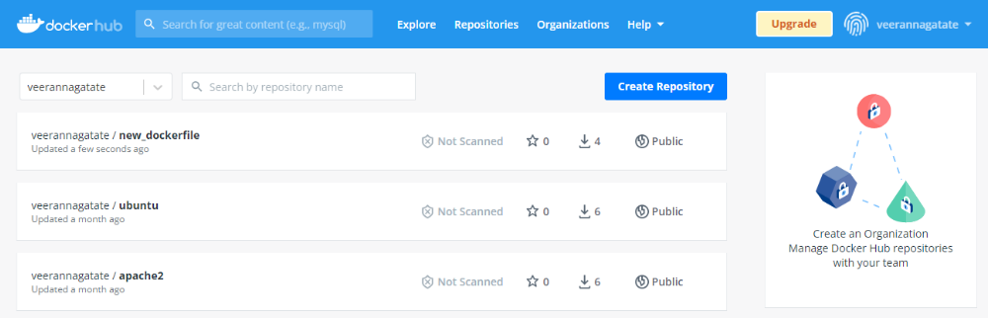
ubuntu@ip-172-31-28-92:~$ sudo nano kubedocker.yaml
apiVersion: apps/v1
kind: Deployment
metadata:
name: custom-deployment
labels:
app: custom
spec:
replicas: 2
selector:
matchLabels:
app: index.html
template:
metadata:
labels:
app: index.html
spec:
containers:
- name: ubuntu
image: veerannagatate/new_dockerfile
ports:
- containerPort: 81
ubuntu@ip-172-31-28-92:~$ kubectl apply -f kubedocker.yaml
deployment.apps/custom-deployment created
ubuntu@ip-172-31-28-92:~$ sudo nano apache-service.yaml
ubuntu@ip-172-31-28-92:~$ kubectl apply -f apache-service.yaml
service/apache-service unchanged
ubuntu@ip-172-31-28-92:~$ kubectl apply -f custom-service.yaml
service/custom-service created
ubuntu@ip-172-31-28-92:~$ sudo nano ingress.yaml
ubuntu@ip-172-31-28-92:~$ kubectl apply -f ingress.yaml
Warning: extensions/v1beta1 Ingress is deprecated in v1.14+, unavailable in v1.22+; use networking.k8s.io/v1 Ingress

